Programming Assignment 1

Gaussian Kernels

The Gaussian Kernels were implemented using:

* Gaussian Density formula:
$f(x) = \frac{1}{(\sqrt{2Π} ) σ}e(\frac{{-x}^{2}}{2σ^{2}})$

* Derivative of the Gaussian Density formula:

$f '(x) = \frac{-x}{σ^{2}}f(x)$

Both the gaussian and the first derivative of gaussian functions return a numpy array of length 5. Instead of calculating a 2D kernel, a 1D kernel was calculated and used in both the x and y directions of the image, which decreased the computational complexity of this function.

Convolutions

The convolution function accepts an image and a 1D kernel as inputs, and returns two images, one where the kernel was convolved in the X direction and the other convolved in the Y direction.

Procedure:

1. Pad the image with floor(kernel size / 2) rows of padding to the left, right, top, and bottom of the image to maintain the original image size in the return matrix
2. Initialize two zero matrices for each of the convolution directions
3. Iterate over all the rows
4. Iterate over all the columns
5. Compute the linear combination of the image and the kernel in the X direction and place the solution in the center of the current filter position on the image
6. Compute the linear combination of the image and the kernel in the Y direction and place the solution in the center of the current filter position on the image
7. Return the two convolved images as a tuple (X image, Y image)

Magnitude

The magnitude function computes and returns a magnitude matrix. It accepts two matrices as inputs. For each pixel location in each image, the function computes the magnitude:

$Magnitude = \sqrt{X^{2}+ Y^{2}}$

Then, the magnitude value is saved in the same pixel position of the resultant matrix.

Orientation

The orientation function computes the arctan of two gradient matrices. The computed matrix is comprised of radian values, so the orientation matrix is converted to degrees by multiplying the matrix by $\frac{180}{Π}$. The resultant direction values are between 0 - 2𝚷, all pixel location with a negative value is rotated 180° so that it is a positive value within the range of 0-𝚷. This was accomplished by adding 180 to each negative degree value. The resulting orientation matrix is then returned.

Non-Max Suppression

The Non-max suppression algorithm accepts a magnitude matrix and an orientation matrix. Using the orientation matrix, the algorithm categorizes the matrix values from 0-45°, 45-90°, 90-135°, and 135-180°. Whichever category the current pixel value lies in determines the direction of the neighbors. If the value at the current pixel is larger than both of its neighbors in the direction of its normal vector, then that pixel is a true edge and its magnitude value is saved in the new image. After all the pixels have been processed, the resulting matrix is returned.

Hysterisis Thresholding

This algorithm was implemented by using the non max suppression matrix from the previous step, along with optional lower threshold and higher threshold values. Strong and weak pixel values are marked as 255 and 100 respectively. Then, the algorithm iteratively processes each pixel location. If the location is a weak pixel value, all surrounding pixels are checked for strong pixel values, using 8-way connectivity. If any of the neighboring pixels are strong, then the value at the current pixel will be changed to 255. The resulting canny image is returned.

Results

**Sigma = 2**

* Gaussian Filter in X direction

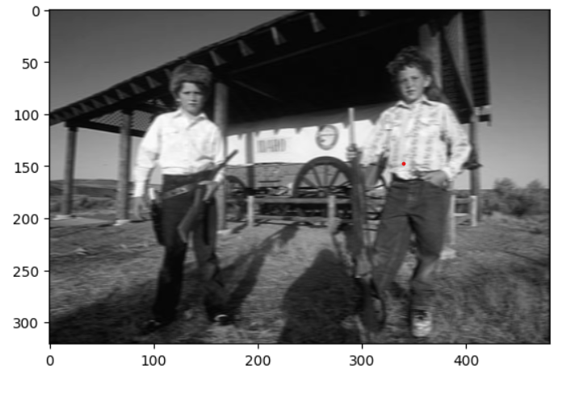

* Gaussian Filter in Y direction

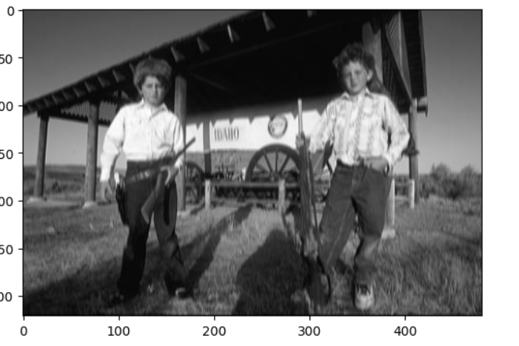

* Derivative of Gaussian Filter in X direction

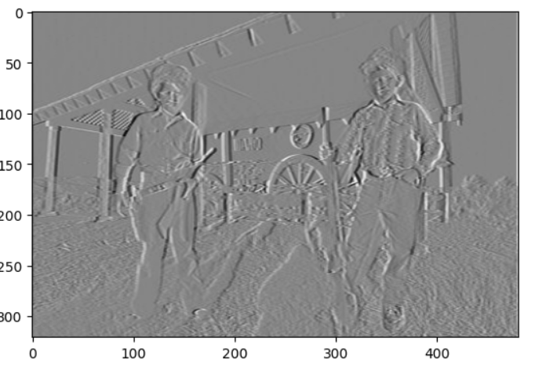

* Derivative of Gaussian Filter in Y direction

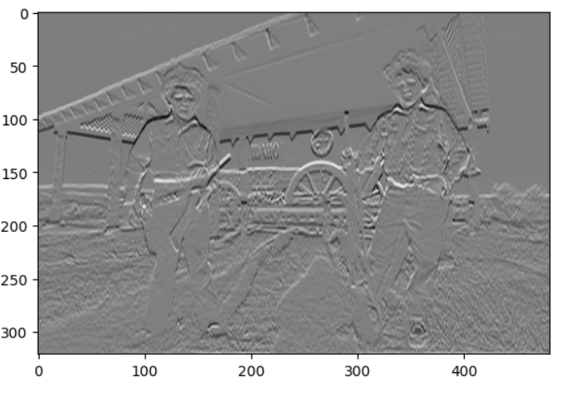

* Magnitude

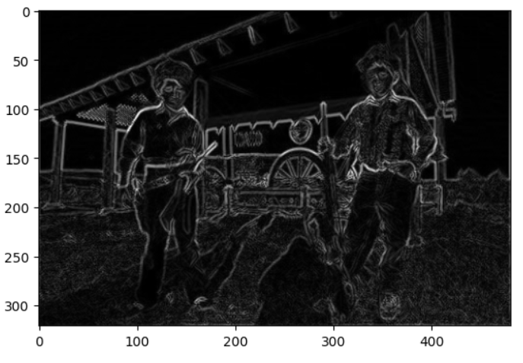

* Non-Max Suppression

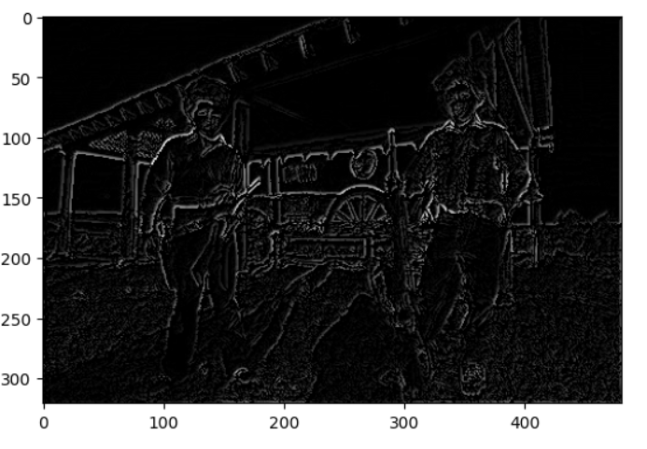

* Hysterisis Thresholding

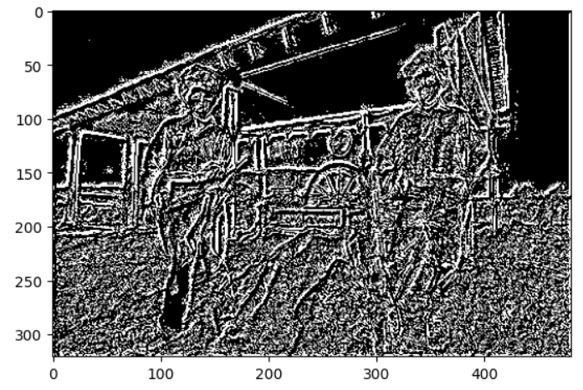

* Gaussian Filter in X direction

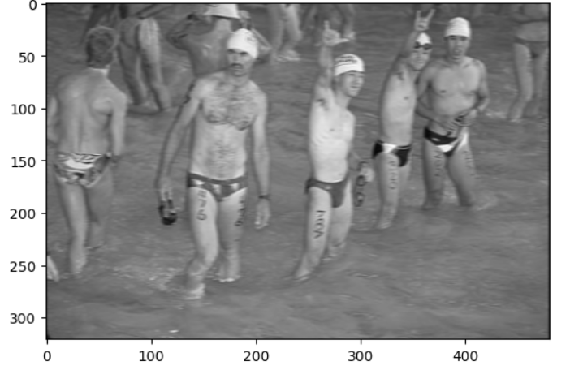

* Gaussian Filter in Y direction

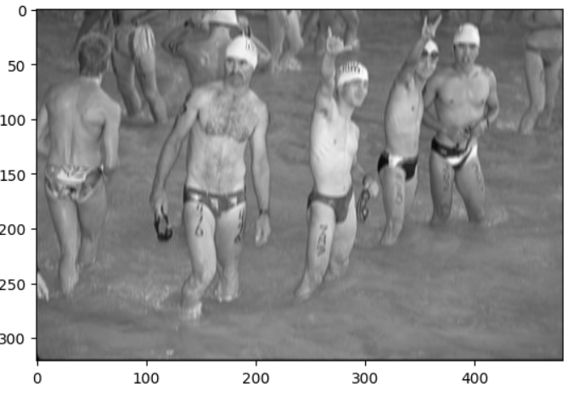

* Derivative of Gaussian Filter in X direction

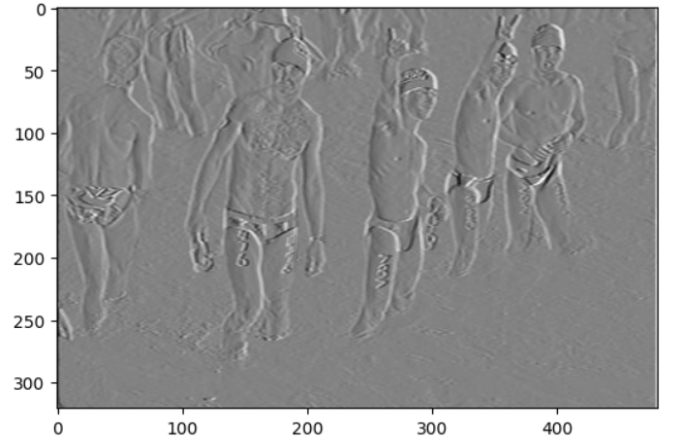

* Derivative of Gaussian Filter in Y direction

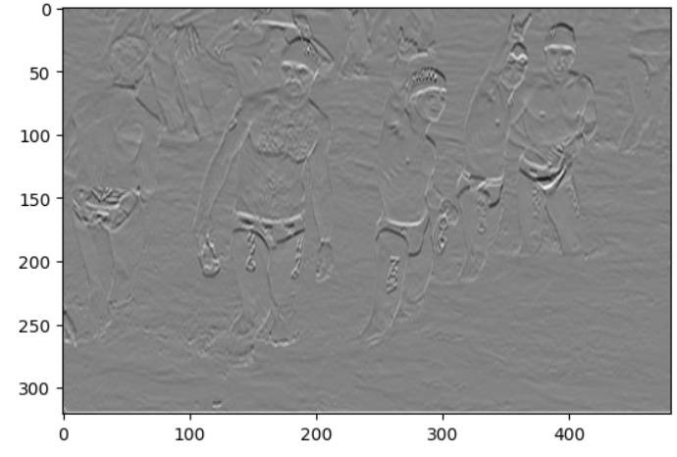

* Magnitude

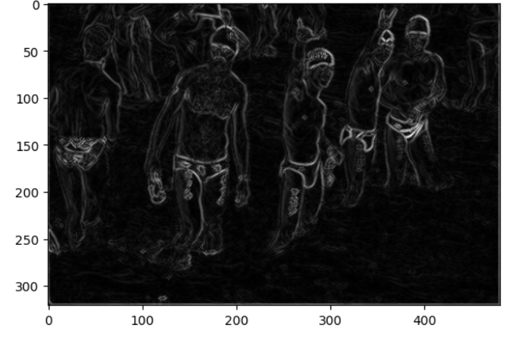

* Non-max Suppression

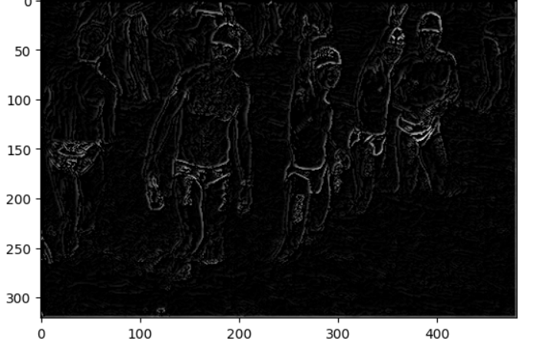

* Hysterisis Thresholding

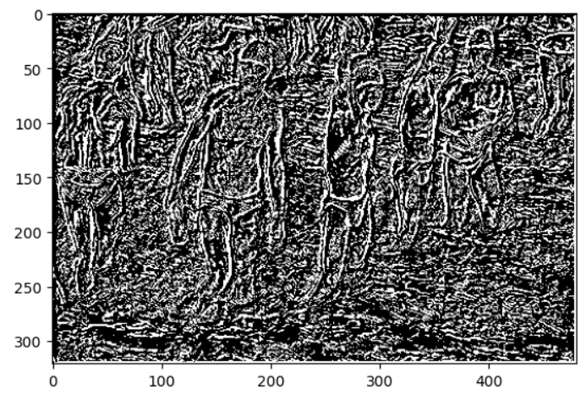

* Gaussian Filter in X direction

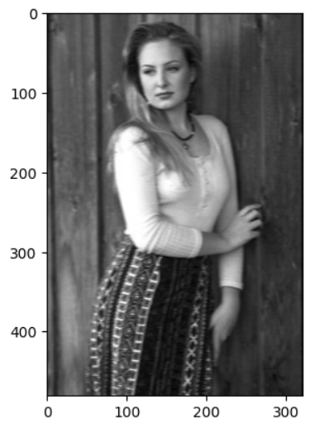

* Gaussian Filter in Y direction

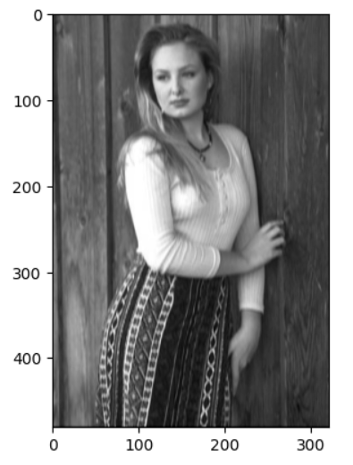

* Derivative of Gaussian Filter in X direction

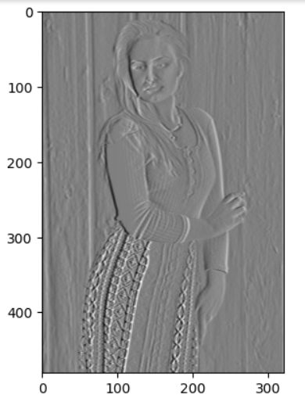

* Derivative of Gaussian Filter in Y direction

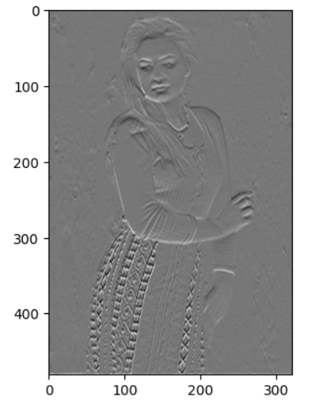

* Magnitude

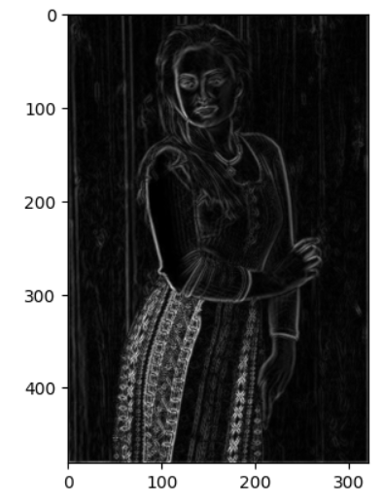

* Non-max Suppression

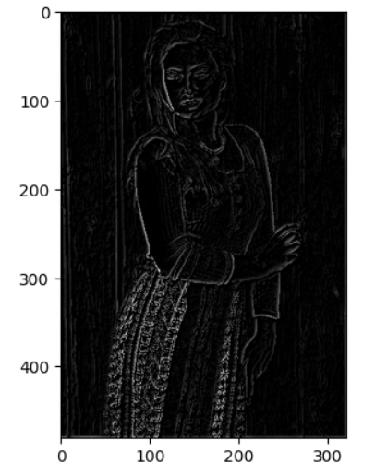

* Hysterisis Thresholding

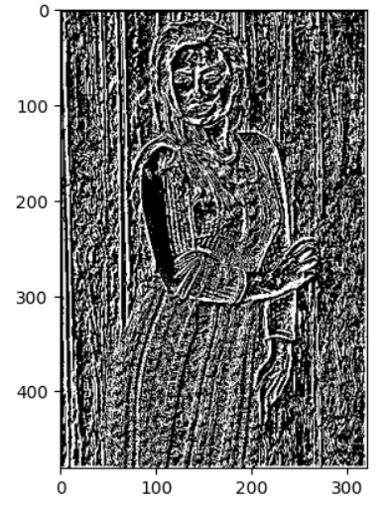

**Sigma = 4**

* Gaussian Filter in X direction

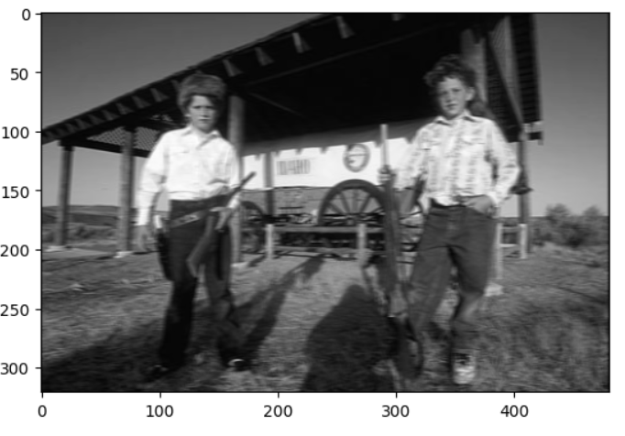

* Gaussian Filter in Y direction

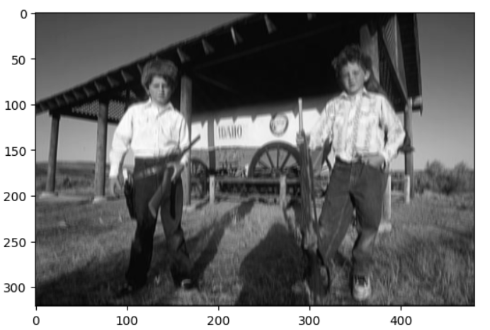

* Derivative of Gaussian Filter in X direction

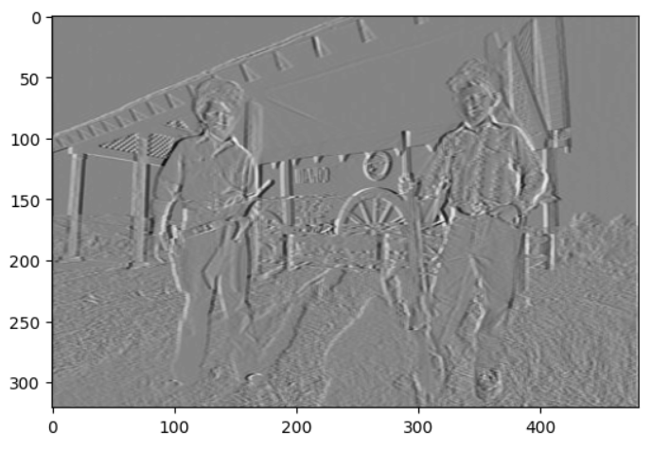

* Derivative of Gaussian Filter in Y direction

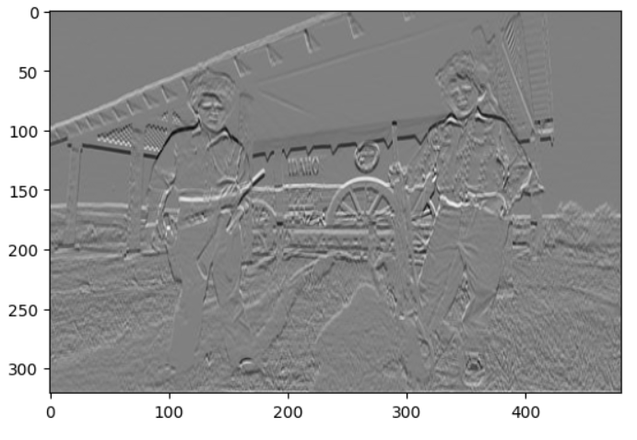

* Magnitude

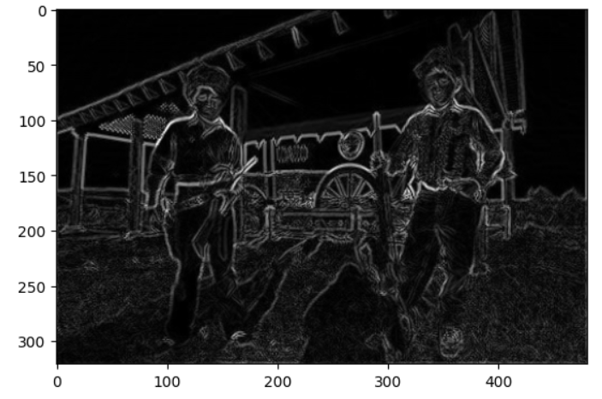

* Non-Max Suppression

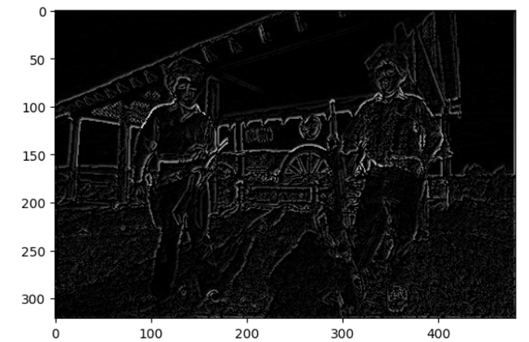

* Hysterisis Thresholding

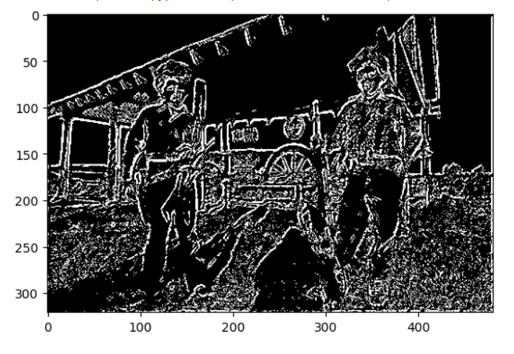

* Gaussian Filter in X direction

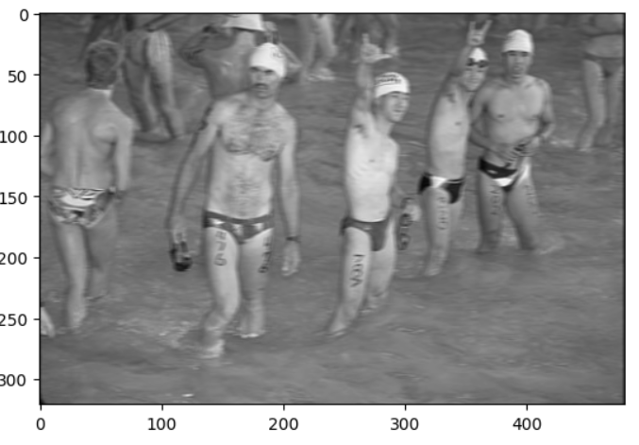

* Gaussian Filter in Y direction

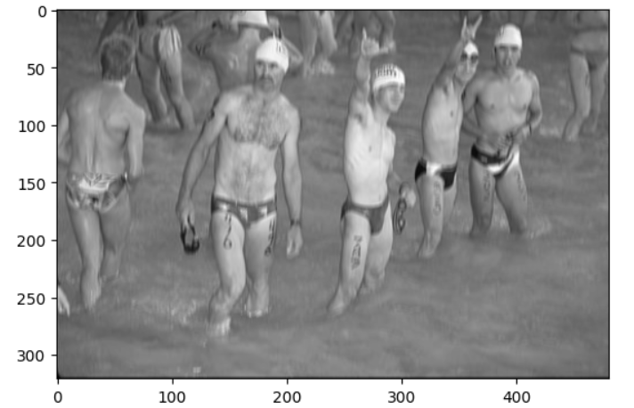

* Derivative of Gaussian Filter in X direction

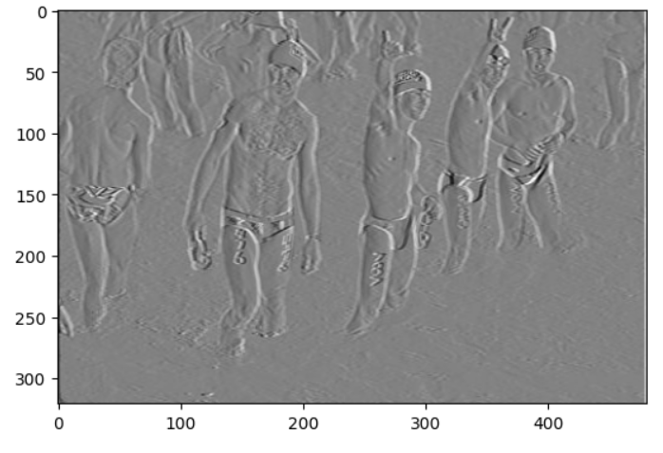

* Derivative of Gaussian Filter in Y direction

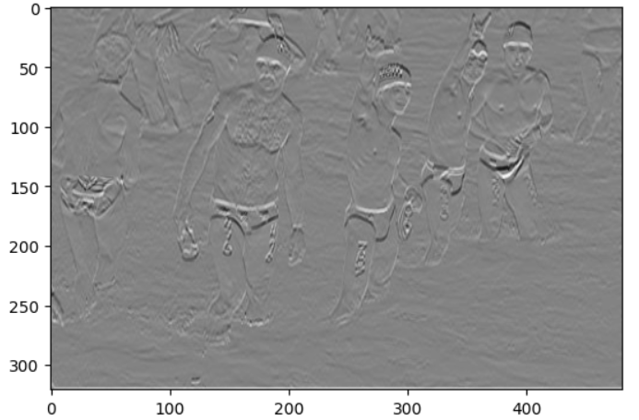

* Magnitude

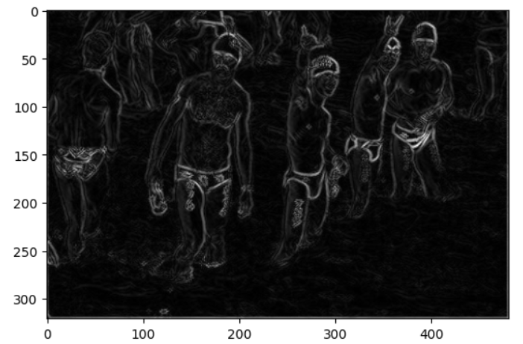

* Non-max Suppression

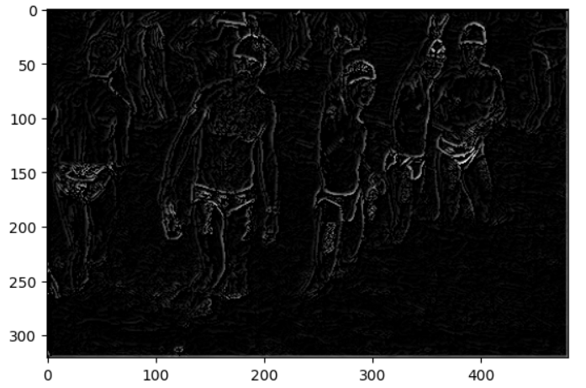

* Hysterisis Thresholding

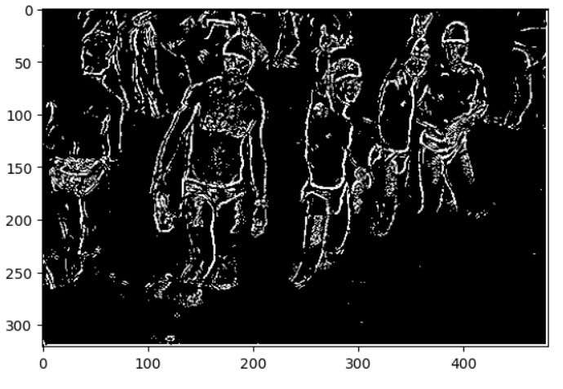

* Gaussian Filter in X direction

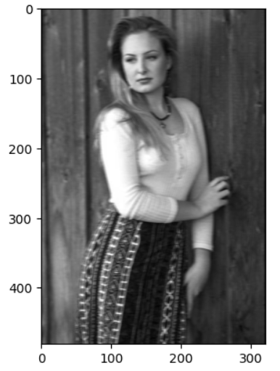

* Gaussian Filter in Y direction

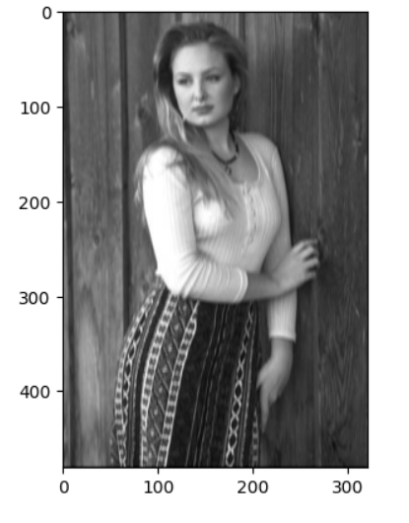

* Derivative of Gaussian Filter in X direction

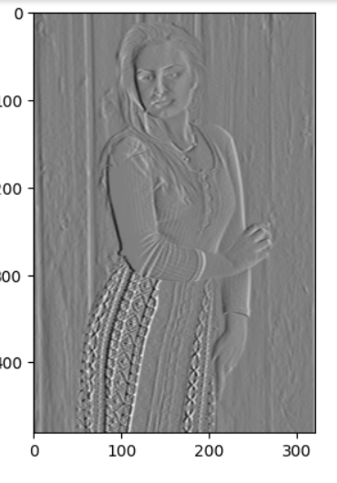

* Derivative of Gaussian Filter in Y direction

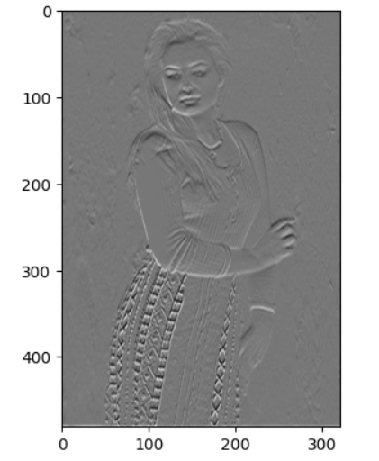

* Magnitude

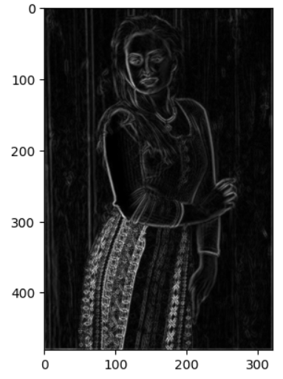

* Non-max Suppression

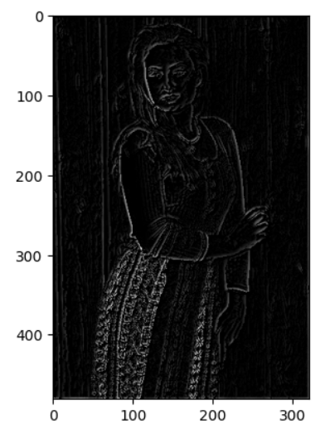

* Hysterisis Thresholding

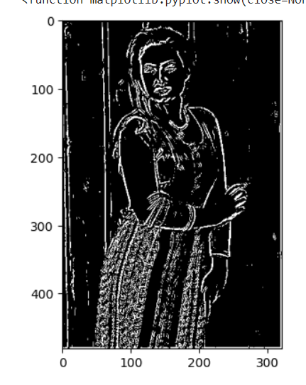

**Sigma = 6**

* Gaussian Filter in X direction

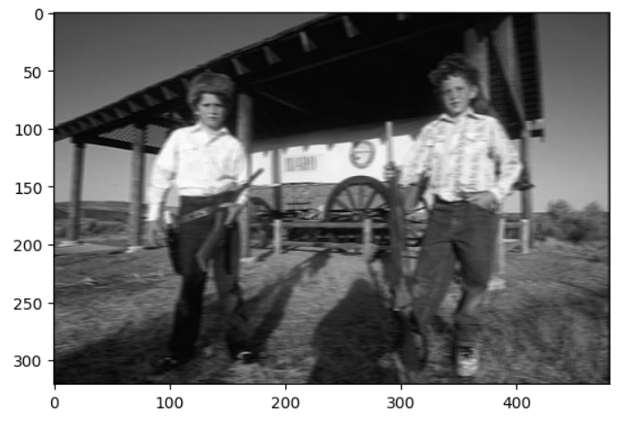

* Gaussian Filter in Y direction

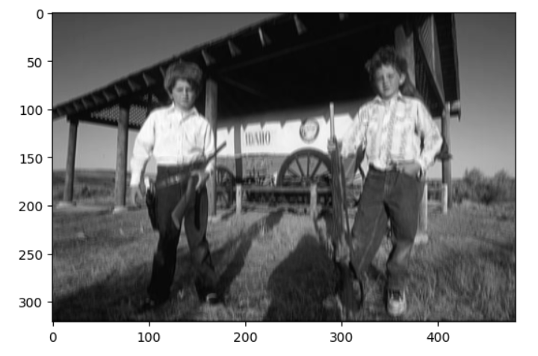

* Derivative of Gaussian Filter in X direction

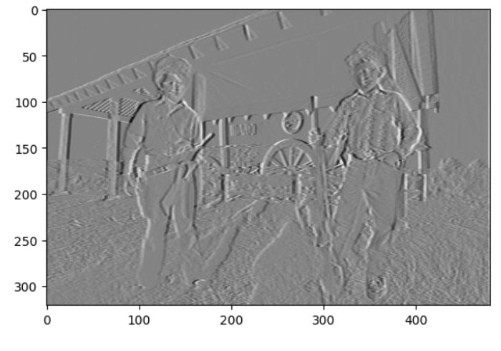

* Derivative of Gaussian Filter in Y direction

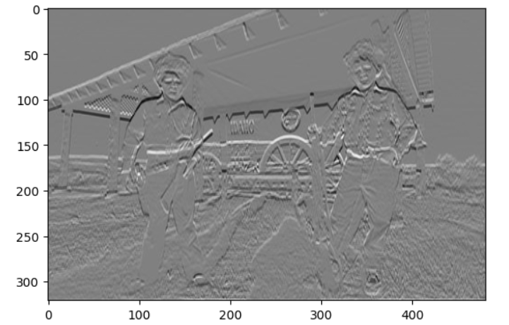

* Magnitude

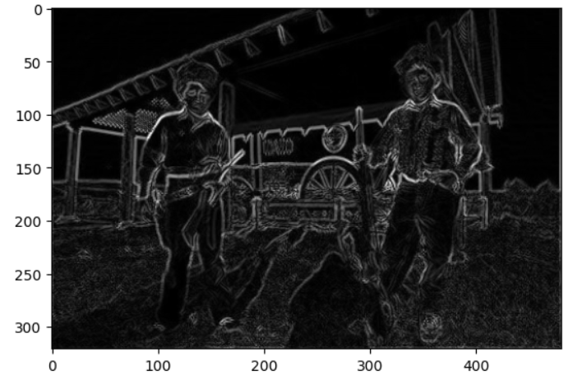

* Non-Max Suppression

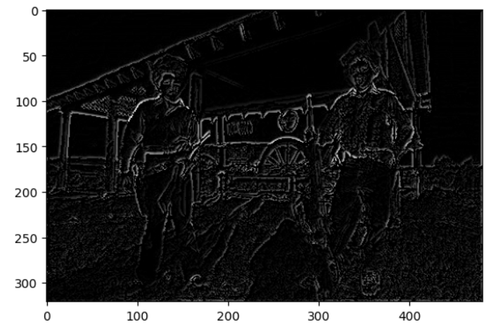

* Hysterisis Thresholding

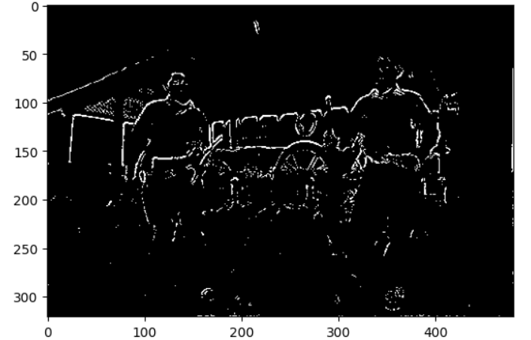

* Gaussian Filter in X direction

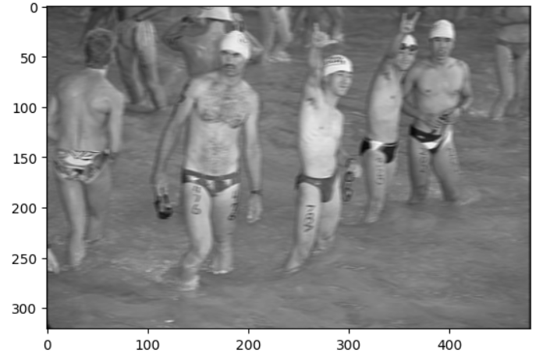

* Gaussian Filter in Y direction

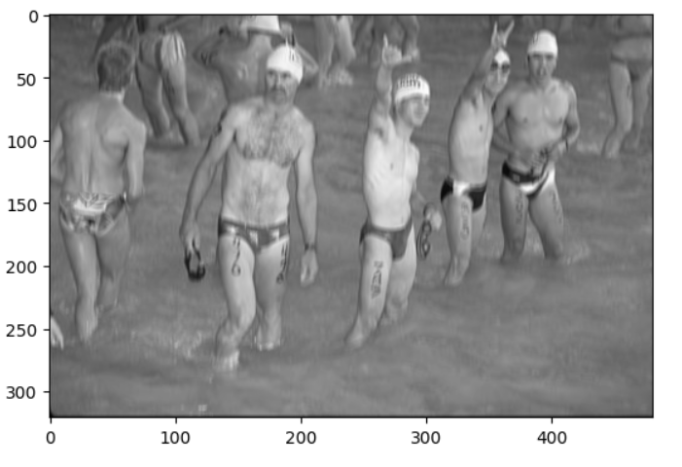

* Derivative of Gaussian Filter in X direction

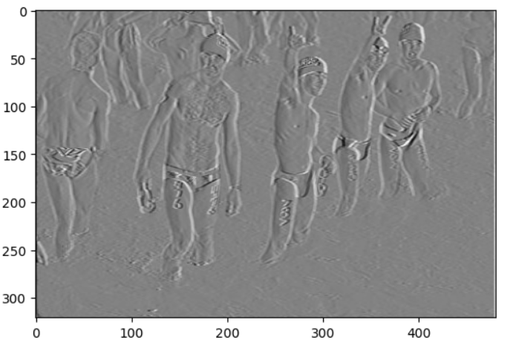

* Derivative of Gaussian Filter in Y direction

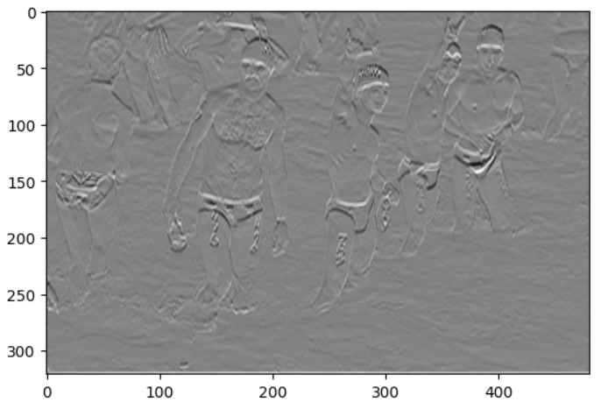

* Magnitude

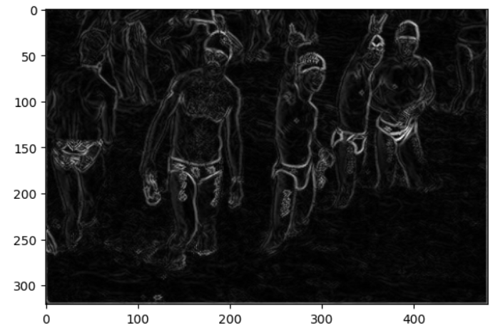

* Non-max Suppression

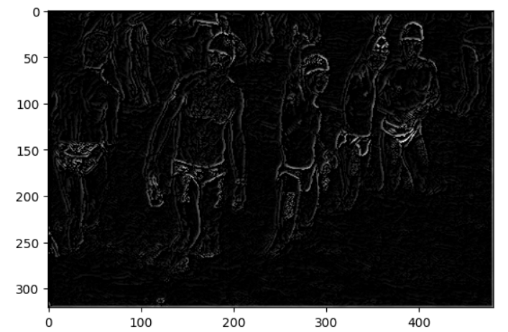

* Hysterisis Thresholding

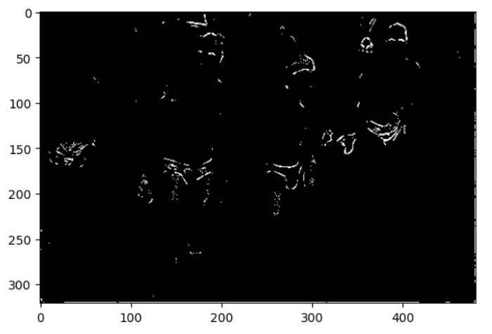

* Gaussian Filter in X direction

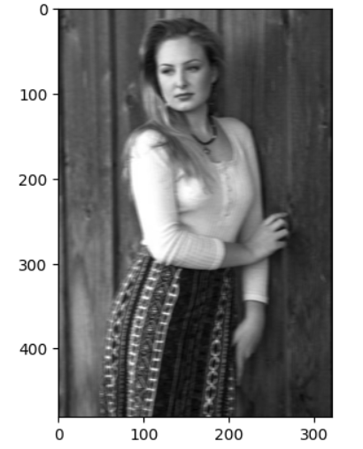

* Gaussian Filter in Y direction

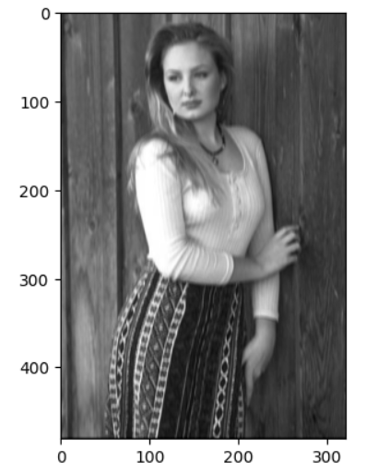

* Derivative of Gaussian Filter in X direction

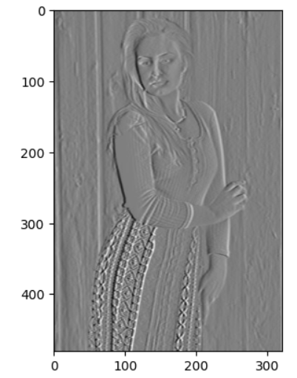

* Derivative of Gaussian Filter in Y direction

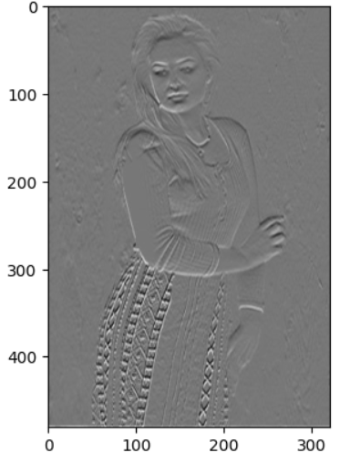

* Magnitude

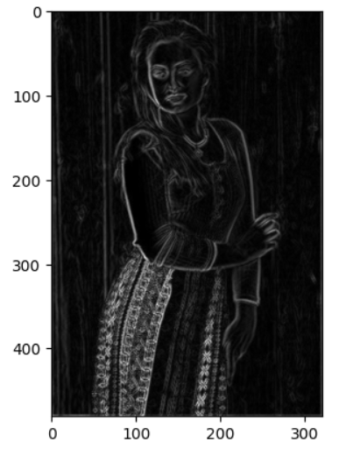

* Non-max Suppression

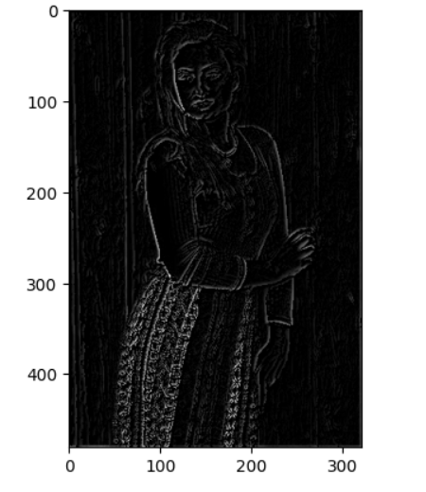

* Hysterisis Thresholding

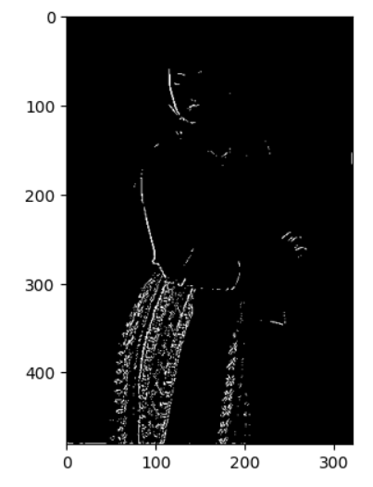

Conclusion

In the experiment, using a sigma value of 4 gave the best overall results. Although a lot of the edge features were lost in that model, the majority of false edges were eliminated. More tuning needs to be done with the higher and lower thresholds, as well as different kernel sizes to fine tune this model.